**ASSIGNMENT**

**NM ID:** [06DBAEDBE1E3FCC941F438ABBDEA66A4](https://naanmudhalvan.tn.gov.in/reports/dashboard/student/detail/06DBAEDBE1E3FCC941F438ABBDEA66A4/)

**NAME: ATHISH R**

**1.Website using wordpress -**

**Link:** <https://mesmerizingmusic0.wordpress.com>

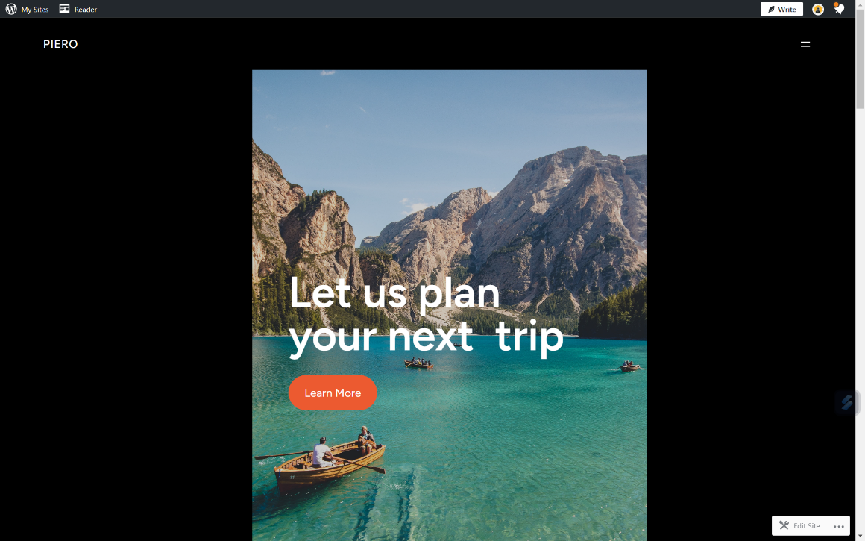

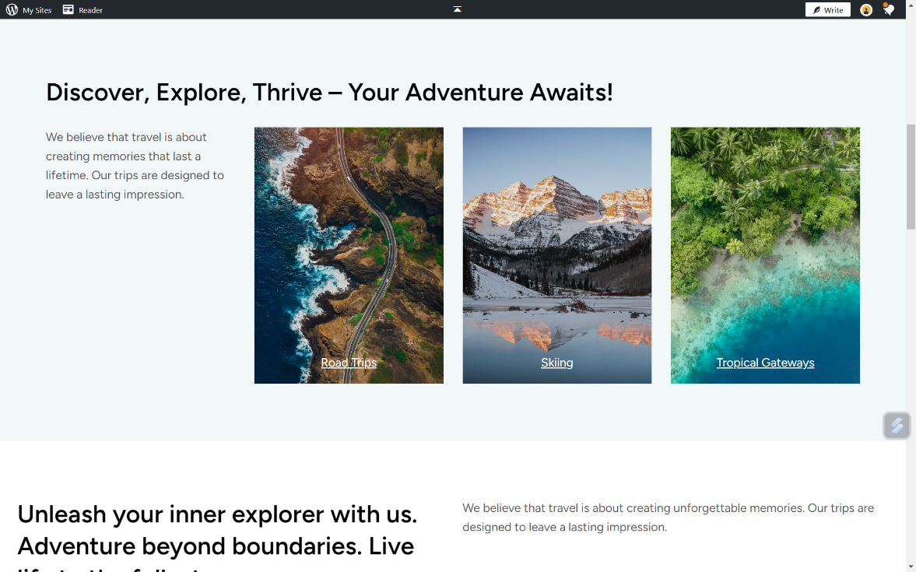

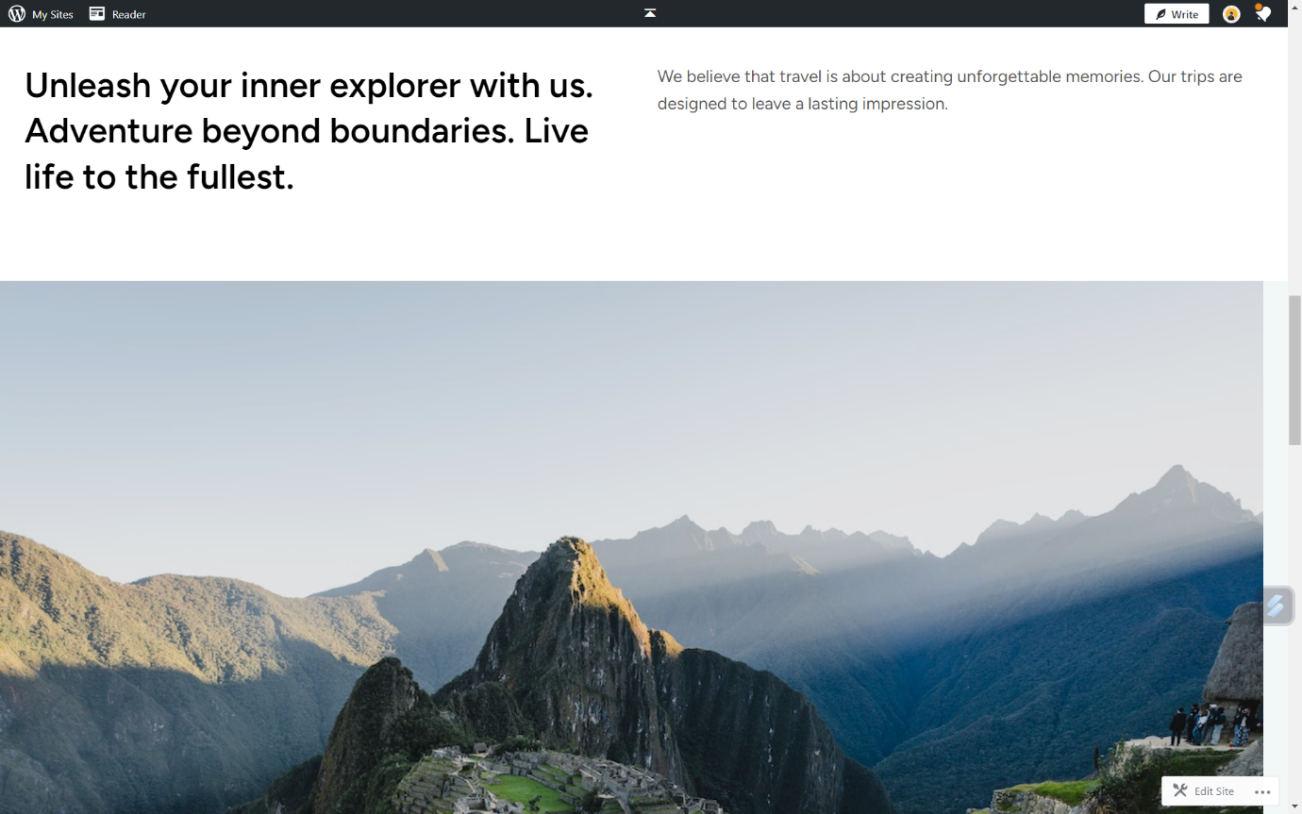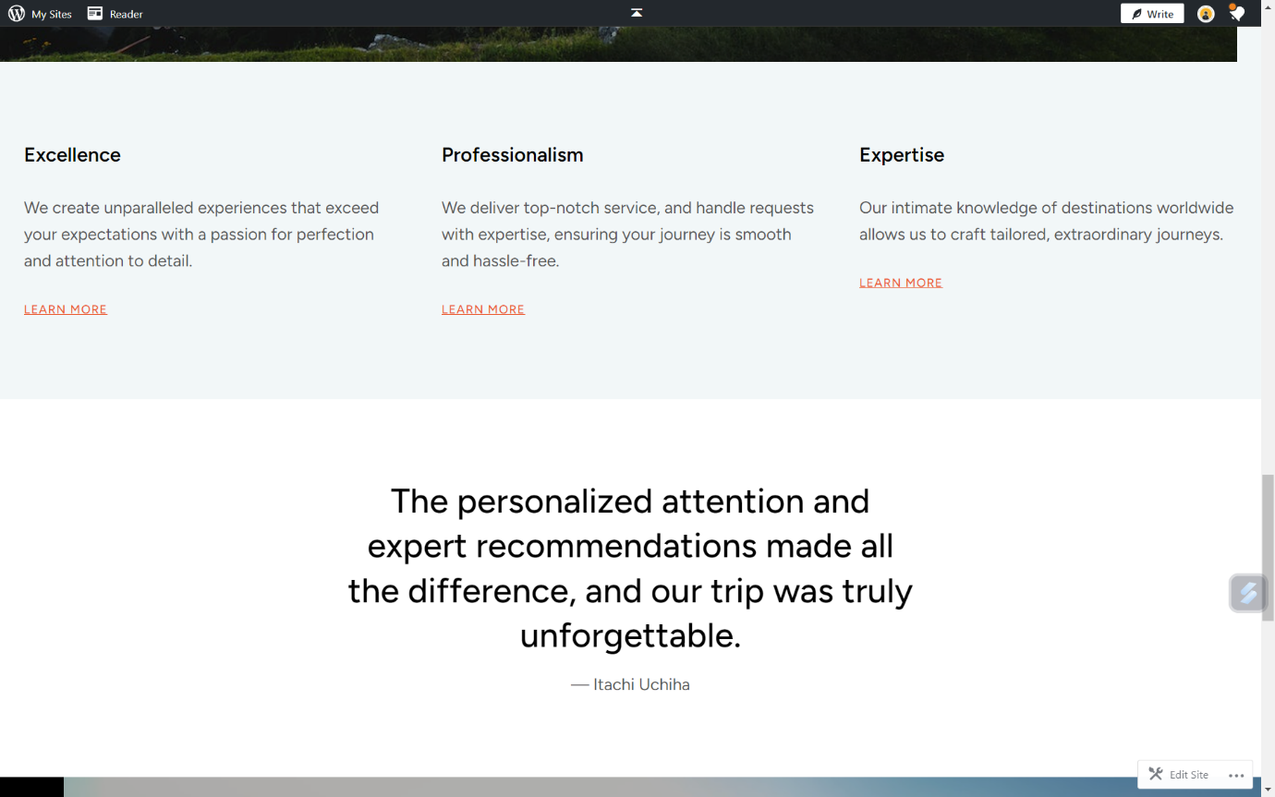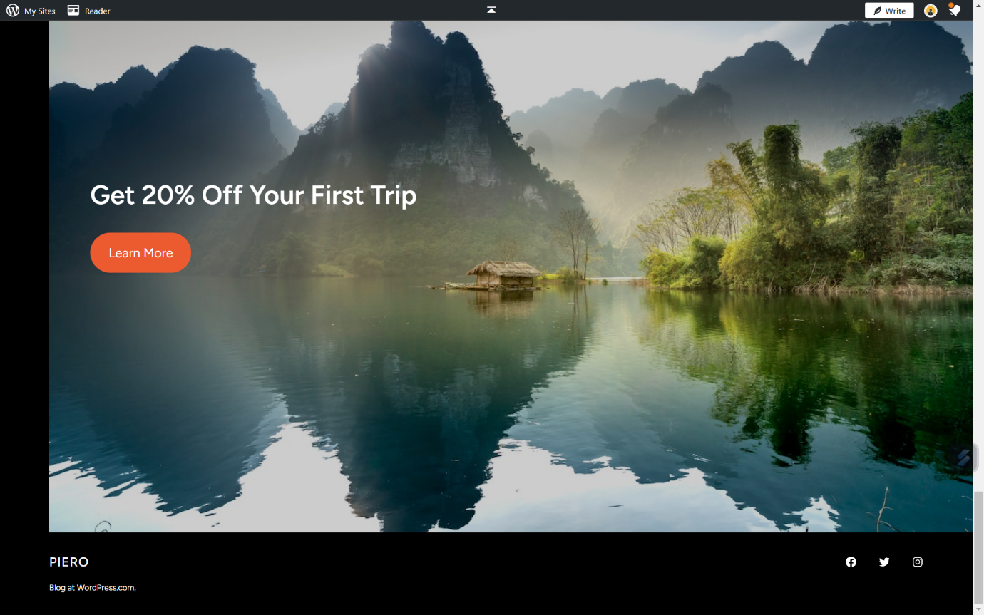

**2.Create a new facebook business page and post one social media poster for**

**your brand.**

**Link :** [**https://www.facebook.com/profile.php?id=61552563075545**](https://www.facebook.com/profile.php?id=61552563075545)

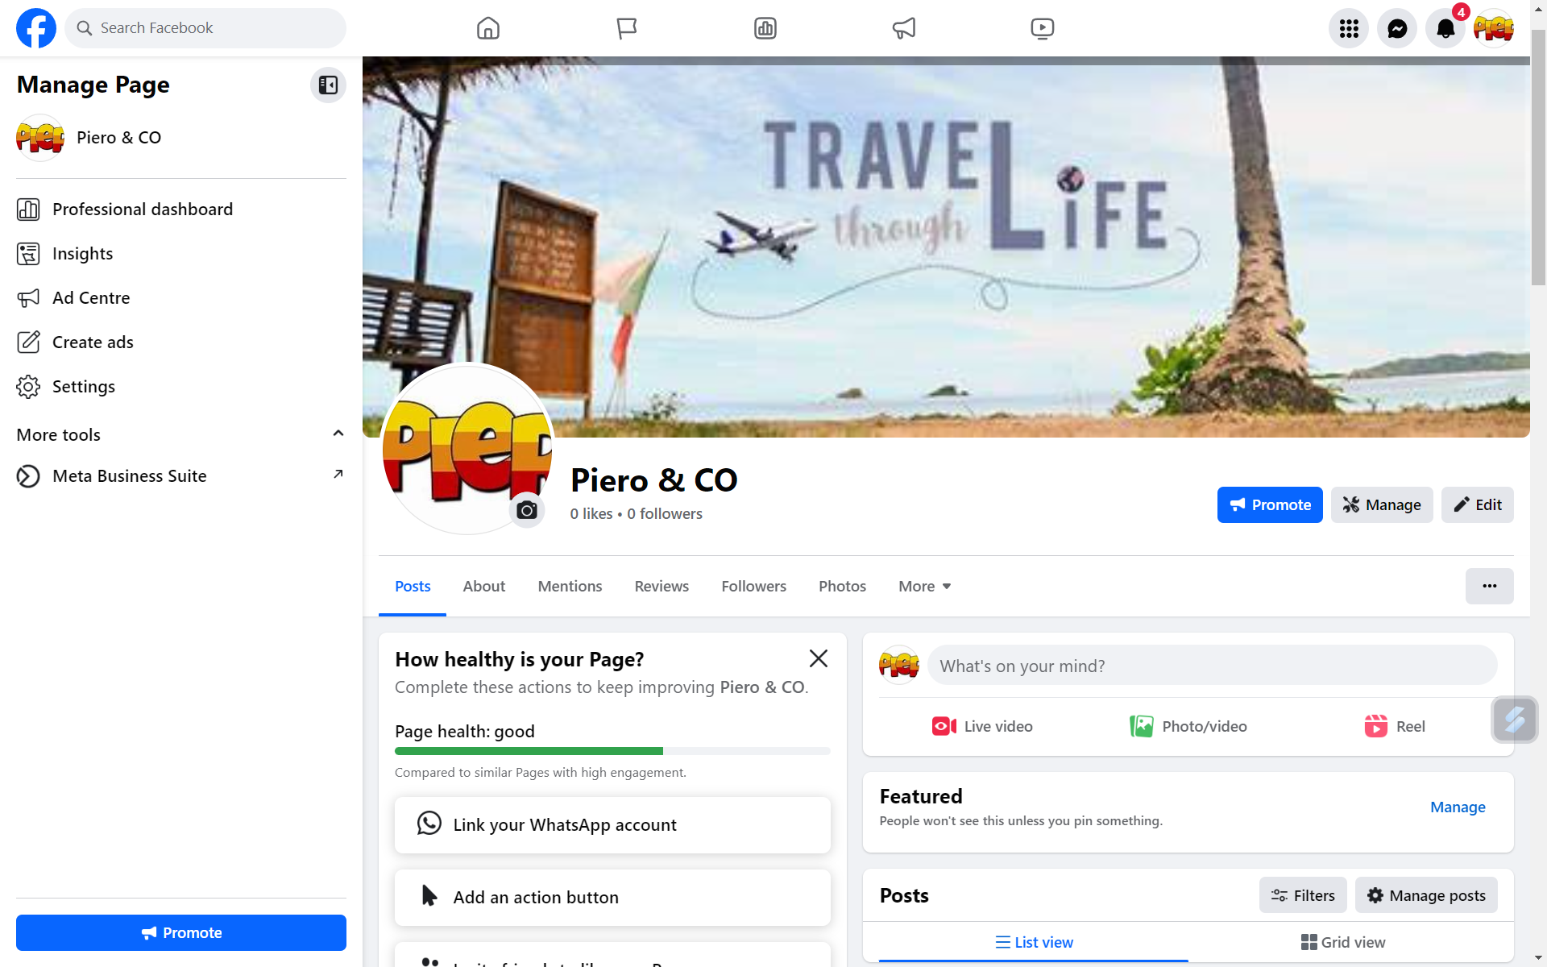

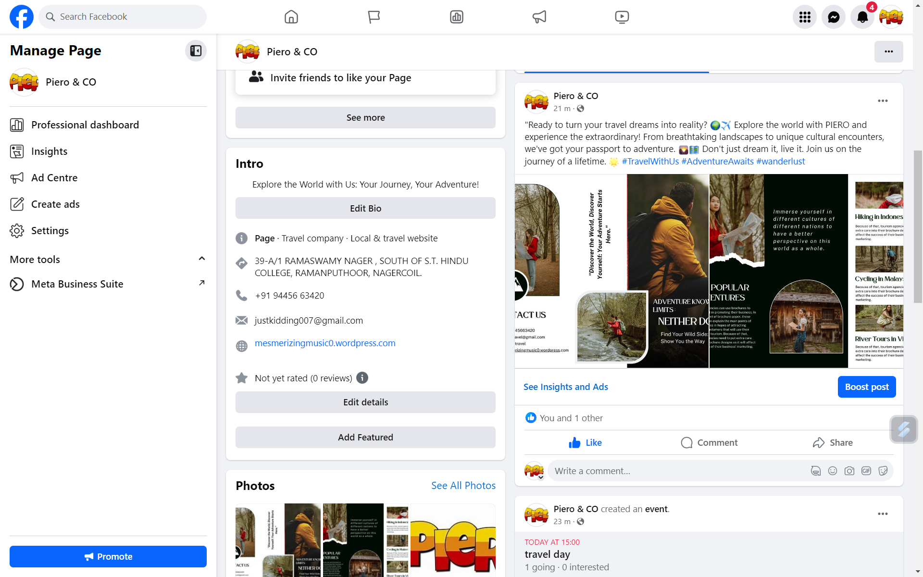

**3.Create and design a social media advertisement poster using canva**

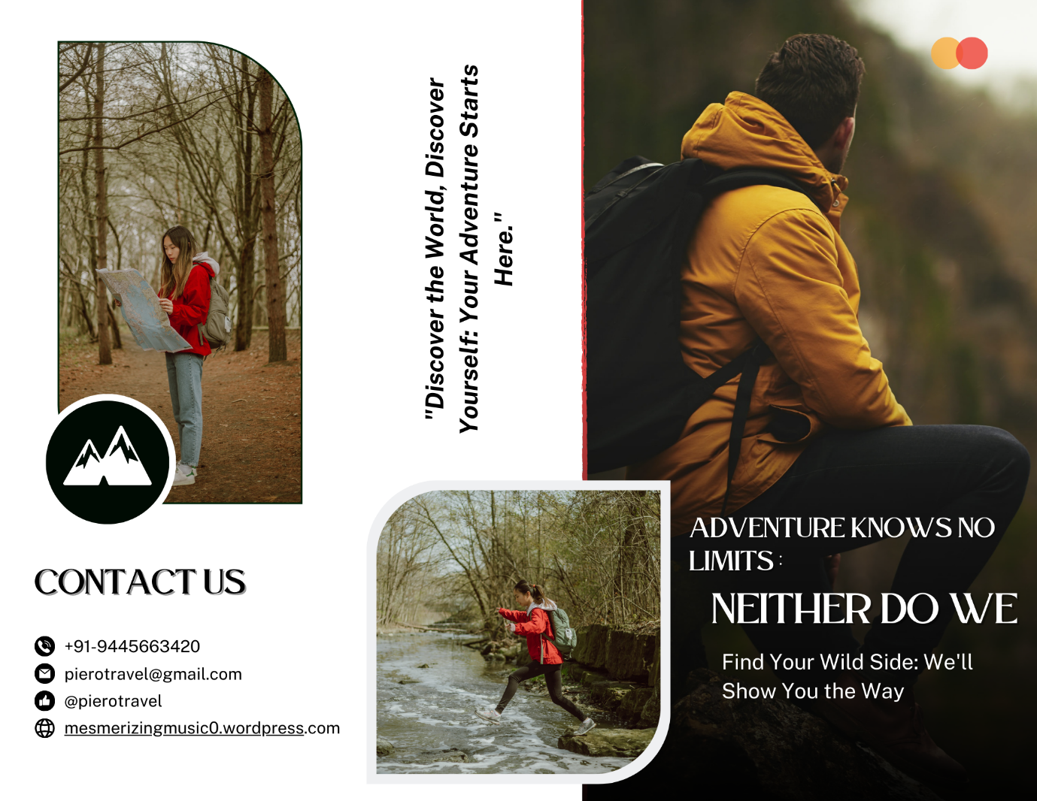

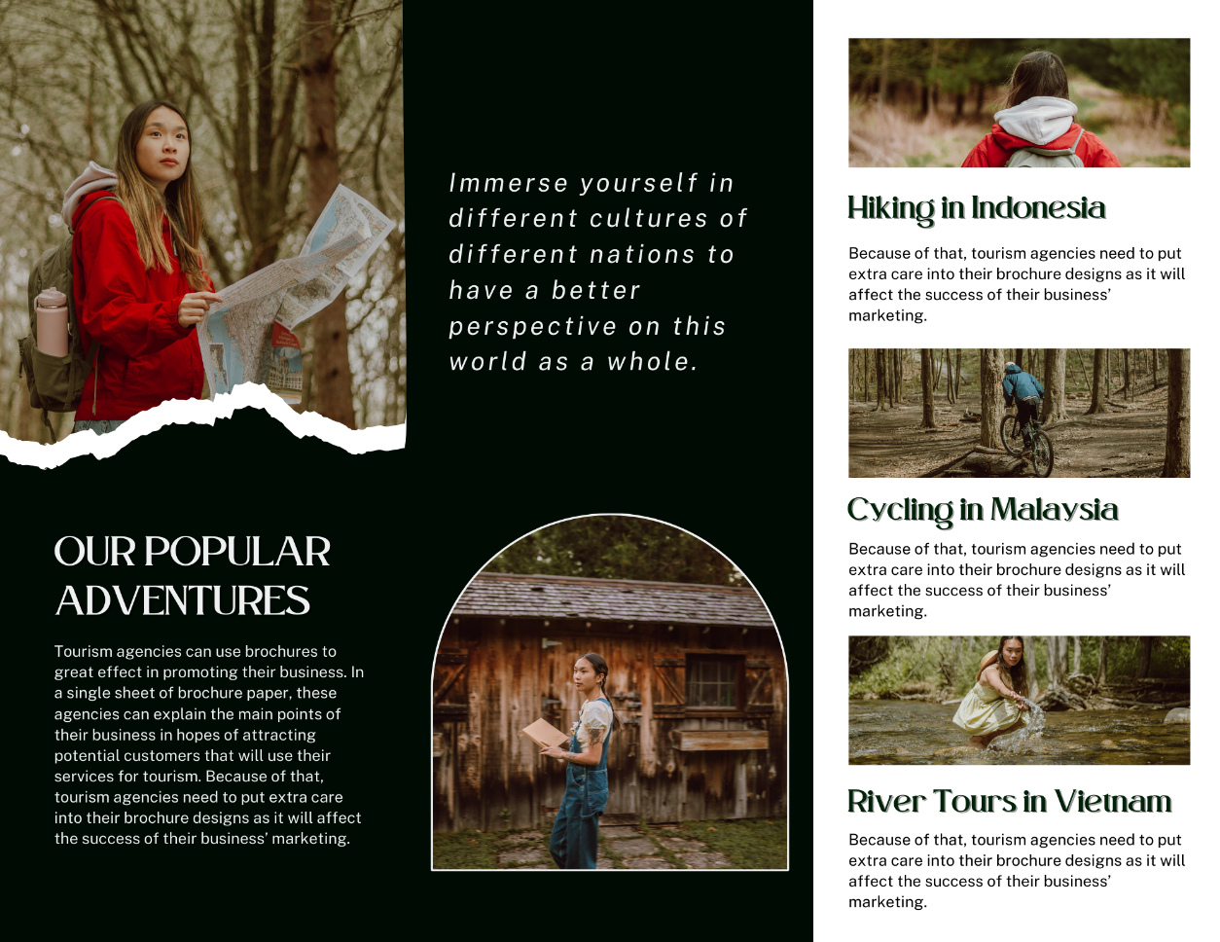

**4.Create email newsletter design using mailchimp or canva tool.**

